**Software Requirements and Design Document**

**For**

**Group 2**

Version 3.1

**Authors**:

Zachary Ortiz

Rafe Ewert

Joe Sahl

# Overview (5 points)

The game is a recreation of Super Mario Bros from the NES, and is being built in Godot, a game engine that supports 2D platformers. It is being written in Godot’s own language, GDScript. The game will have three levels: Overworld, Underground, and Castle. Each level will have its respective difficulties due to certain elements, such as enemy count, obstacle count, and item count. (Z) Items should not carry over from one level to another

# Functional Requirements (10 points)

1. Player must have control over Mario, so that based upon key input, he reacts accordingly (High) (Z)
2. Player must be able to start and quit the game on a title menu (High) (Z)
3. Mario must have proper collision and behavior with enemies, items, and obstacles (High) (Z)
4. Enemies must behave similarly to the original game. (High) (J)
5. Bowser must shoot fireballs at Mario on the final level. (High) (J)
6. Transitions between levels should work so the player can move through all three. (High) (J)

# Non-functional Requirements (10 points)

1. The behavior of Mario must carry across the levels (Z)
2. The game must run decently, i.e. no serious frame drops and no crashing (Z)
3. Transitions must not break the game. (J)
4. Enemies must not have unexpected or unintended behavior. (J)
5. Game should be able to be paused, stopped, and restarted every time a player loses or quits (R)

# Use Case Diagram (10 points)

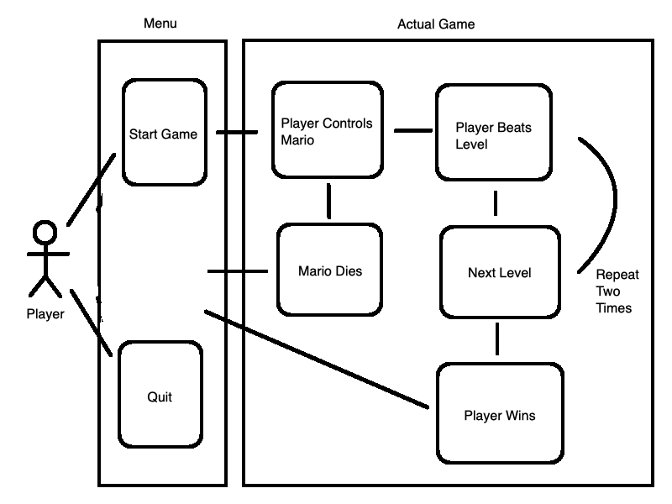Use Case Name: Playing the Game

Actors: Player

Preconditions: Player downloads and starts the game

Normal Flow: Player clicks “Start Game” and takes control of Mario before playing through three levels and winning the game, to which they’ll then be booted back to the main menu

Alternative Flows: Player clicks “Quit” and the game closes, or Mario dies while going through a level, and upon all lives being used up, the Player is shown a “Game Over” screen before being booted back to the main menu

# Class Diagram and/or Sequence Diagrams (15 points)

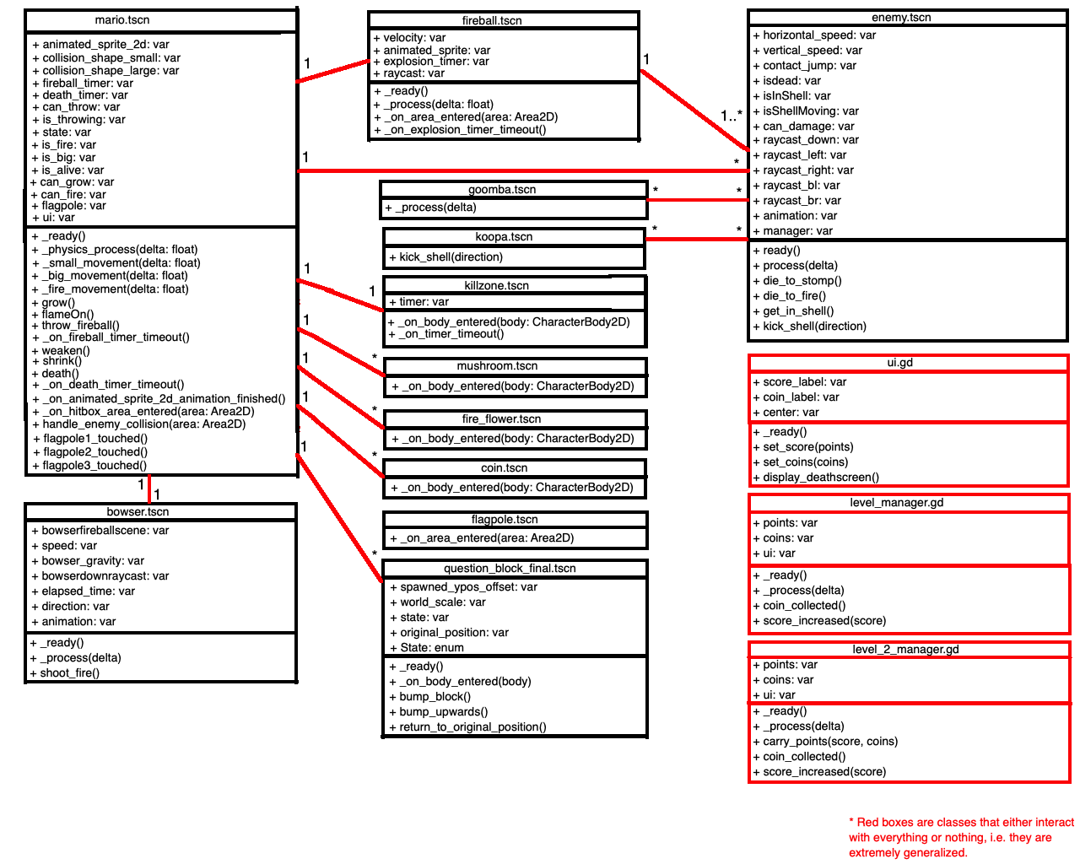

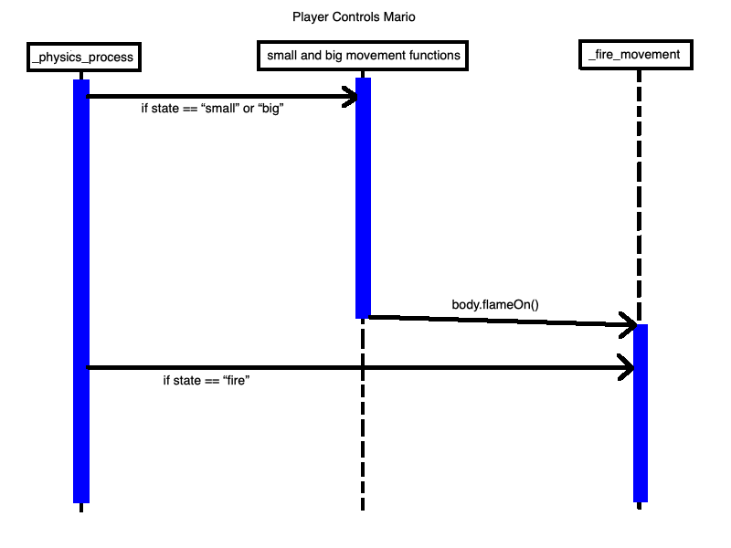

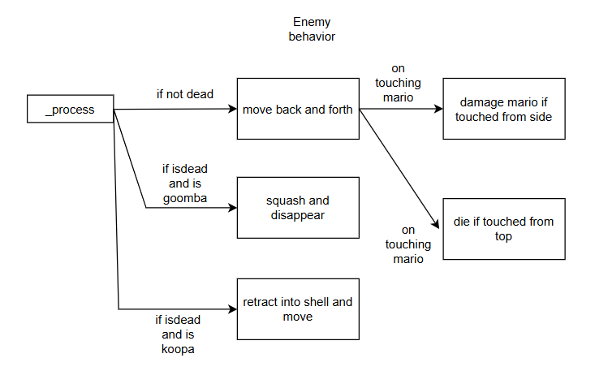

# Operating Environment (5 points)

The game will be playable on any kind of computer, be it desktop, or laptop. It will not run on any other kind of platform. (Z)

The game is an .exe file so it must be run on Windows. (R)

# Assumptions and Dependencies (5 points)

There are no dependencies on other projects, and it is the assumption that the system, or game, will be downloadable from Github and playable that way. (Z)

Assumes the user reads the README.md file on GitHub. (J)